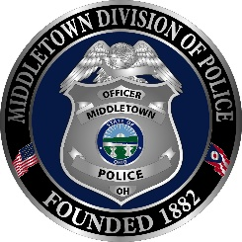
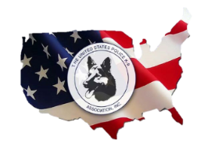
The United States Police Canine Association, Inc
Region 5 Trials
Middletown, Ohio May 15th-20th, 2022
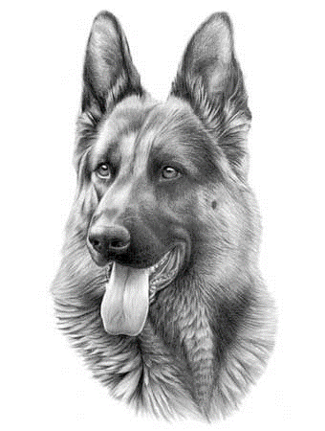
Registration Form
Name: _____________________________ Phone: _____________________________
Address: ___________________________ City: _______________________________
State: ___________ Zip: _____________ Agency: ____________________________
Agency Address:_____________________ City: _______________________________
State: ___________ Zip: ______________ Phone: _____________________________
K-9 Name: __________________________ Age: ________ Breed:________________
All teams must have USPCA membership up-to-date and trial fees paid prior to participating.
Registration Fee:
Will be certifying in (Check all that apply):
☐ Marijuana ☐ No Marijuana
☐ Patrol Dog (PD1) $100 ☐Tracking (PD2) $50 ☐Narcotic Detection $50
☐Explosive Detection $50 ☐ Cadaver Detection $50
Banquet is included. How many guests including yourself will be attending the
Detector Banquet? ____ PD1 Banquet ____

Mail to: Middletown Police Department
ATTN: Teri Gibson
One Donham Plaza
Middletown Ohio 45042
Checks made payable to Middletown FOPA #2

Email Teri Gibson at terig@cityofmiddletown.org for any financial questions.

I hereby waive and relinquish the USPCA and all its Regions and Districts, the Middletown Police Department, and all other event organizers from any injury to myself or K9 while participating in these events. I also agree to abide by the rules established by the USPCA while attending this event. My K9 is currently up to date on all required vaccinations. I accept responsibility for any damage caused by me or my K9 to the hotel, property, or any other person while attending this event.
Signature: __________________________________ Date: __________________________

